PMP exam question1

|  |
| --- |
| As you determine the requirements, constraints and assumptions for the project you record them in which document?  Project scope statement |

|  |
| --- |
| NOT a part of the preliminary scope statement  **A list of requested changes VVV**  A list of project deliverables  The project objectives  A rough order of magnitude cost estimate XXX |

|  |
| --- |
| Information about the project must be distributed to all stakeholders. Which of the following process outputs is used to report the status and cost of project activities?  Ans: Work performance information  Wrong: Status reports |

|  |
| --- |
| One way contract closure differs from **administrative closure** is:  Administrative closure means verifying that the project is complete or terminated; contract closure means verifying that the contract terms were satisfied |

|  |
| --- |
| Which of the following is a **defect**?  A A mistake made by a team member on the job --------Wrong answer  B A change that the team needs to make in how they do the work  **C A project management plan that does not meet its requirements**  D A change request that's been rejected by the change control board  **a defect is any deliverable that does not meet its requirements.** |

|  |
| --- |
| **The nominal group technique** is a form of  brainstorming and vote and rank |

|  |
| --- |
| Variance analysis is a part of the Monitoring and Controlling Process Group. |

|  |
| --- |
|  |

|  |
| --- |
|  |

|  |
| --- |
|  |

|  |
| --- |
|  |

|  |
| --- |
|  |

|  |
| --- |
|  |

|  |
| --- |
|  |

|  |
| --- |
|  |

|  |
| --- |
|  |

|  |
| --- |
|  |

|  |
| --- |
|  |

|  |
| --- |
|  |

|  |
| --- |
|  |

|  |
| --- |
|  |

|  |
| --- |
|  |

## Process: Input, tools and output

### Direct and Manage Project Work process

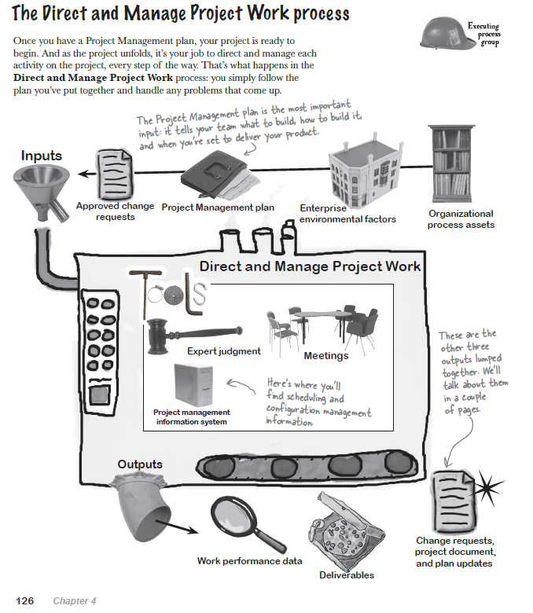

### Manage Stakeholder Engagement

